How To Create Custom VPC in AWS:

Step 1: Login into to AWS account dashboard. To know how to create an AWS account free tier refer to Amazon Web Services (AWS) – Free Tier Account Set up.
Step 2: From the AWS Management Console, type VPC into the search bar and select VPC under the Networking & Content Delivery section.
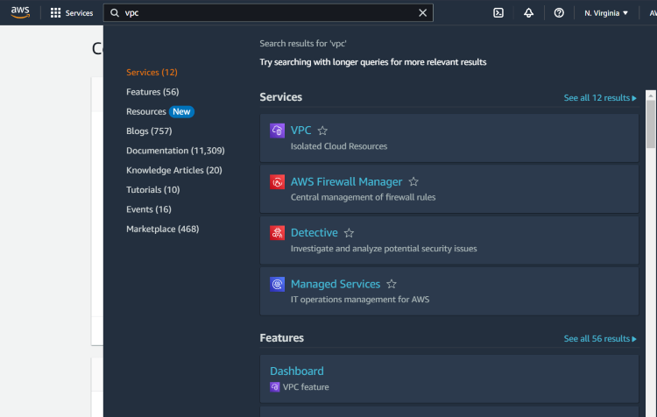
Step 3: In the VPC dashboard, on the left-hand panel, click on Your VPCs and then click the Create VPC button.
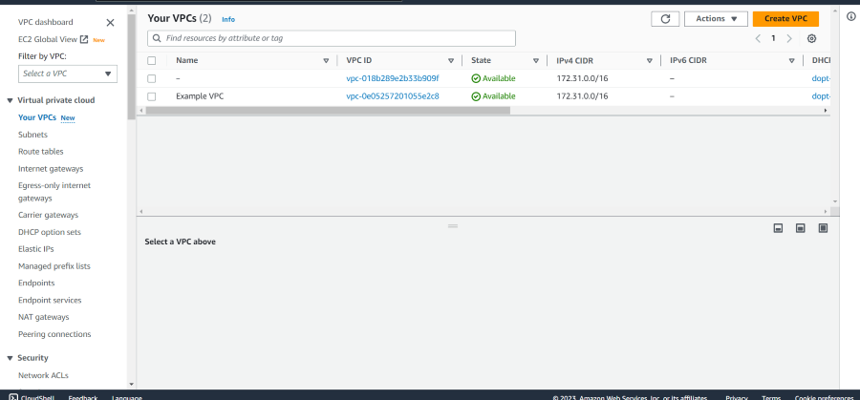
Step 4:
- For Resources to create, choose VPC and more
- For Name tag auto-generation, enter any name you like for example: "Nitin-vpc"
- IPv4 CIDR Block: Enter an IP range for your VPC. A common CIDR block for a VPC is 10.0.0.0/16, which provides 65,536 IP addresses.
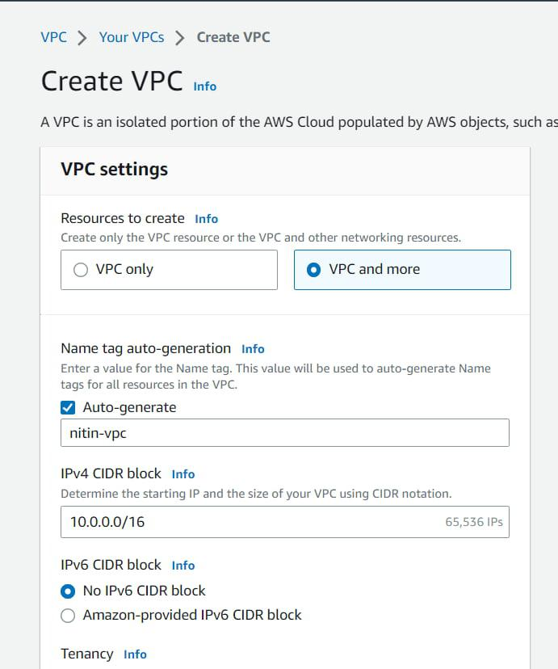
- For Availability Zones (AZs), choose 2.
- For the Number of public subnets, choose 2.
- For the Number of private subnets, choose 2.
- For NAT gateways, choose none
- For VPC endpoints, choose S3 gateway
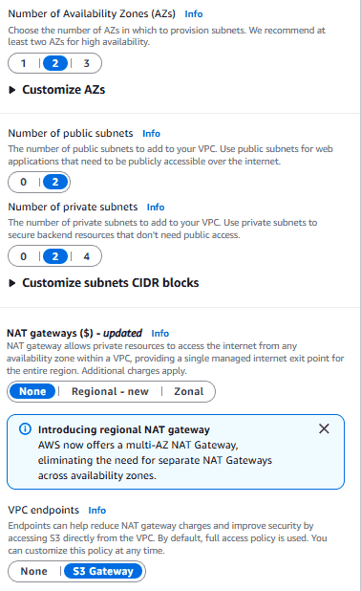VPC Settings
Step 5: AWS will show a diagram preview of your VPC configuration. Review it to ensure that your subnets, CIDR blocks, and settings align with your requirements.
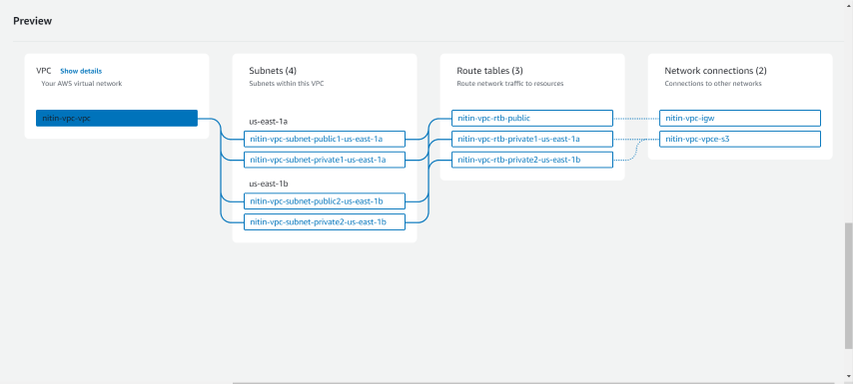
Step 6: After configuring all the options, click Create VPC. AWS will begin creating your custom VPC, which might take a minute or two.
Step 7: Once the creation process is complete, click on View VPC to review your settings and make any necessary changes.
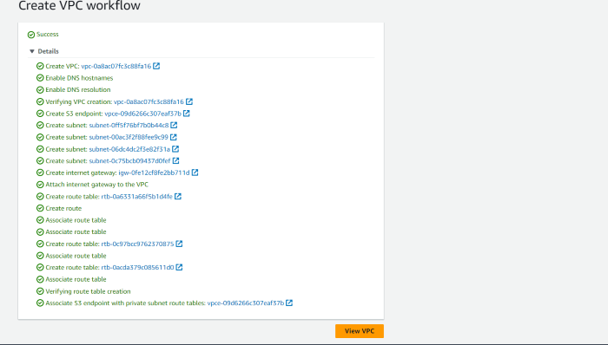
Best Practices After Creation
1. Enable Flow Logs:
- Go to your VPC -> Flow Logs tab -> Create flow log.
- Send logs to CloudWatch. This is critical for troubleshooting connection issues later.
2. Tagging: Ensure all resources (Subnets, Route Tables) are tagged correctly so you know which is Public and which is Private.
3. Network ACLs: Leave the default Network ACL (Allow All) unless you have a specific security requirement. Use Security Groups on your instances for firewalling instead

